**Happiness, Politics and Population**

# Happy and Unhappy countries

Worldwide happiness comes in at an average score of 5.5.

To analyse the differences between those who are happy and who are not.

'More than a halth of all countries have happiness score higher than average. On the other side almost 3/4 of the world population are unhappy. Two most populated countries China (East Asia) and India (South Asia) have happiness score below average. Their total population is about 51% of all unhappy people in the world

**Let's divide all countries into 2 groups:**

1. 'Happy group' - countries with happiness score above average > 5.5328
2. 'Unhappy group' - countries with happiness score below average < 5.5328

Usage of pie chart: Pie chart showing percentages of types of happy, unhappy score of world population. A pie chart expresses a part-to-whole relationship in your data.

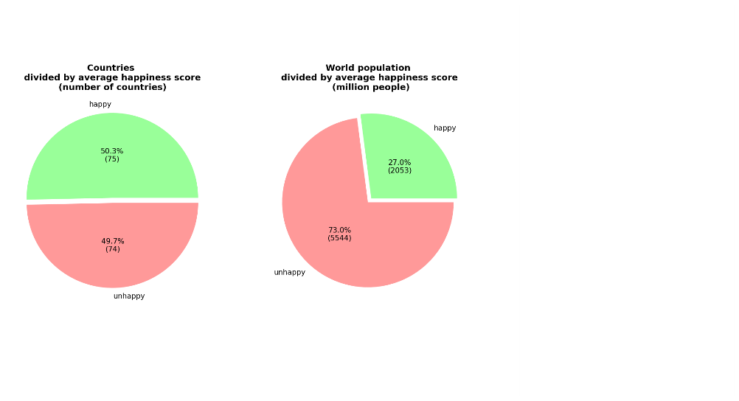

**Urban and rural population**

More than half of the world’s population live in urban areas, increasingly in highly-dense cities

In Happy countries - 77% of the population live in urban areas.

In Unhappy countries - the majority live in rural areas and only 48% of the population live in cities.

I found that urban populations are, on average, happier than rural populations in that they return higher levels of happiness. People in most happy regions are basically live in urban area.

**Usage of bar graph**: The bar graph is used to compare the happy and unhappy countries between different groups. Bar graphs are used to measure the population million people

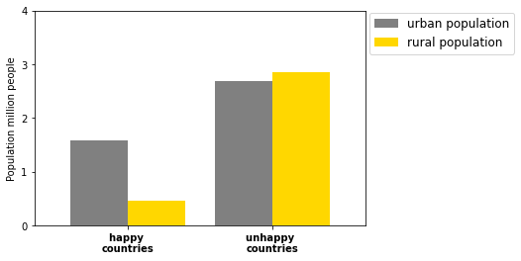

# Regional groups

Let's look on happiness distribution along the world.

The world happiness report distinguishes 10 regional groups. We will analyse and visualise the possible likes between happiness level of the region and 2 life evaluated factors: population and politics.

Highest happiness score gets Western European, North American and ANZ countries.

South Asian countries and Sub-Saharan Africa are at the bottom

**Usage of box plot**: Box plots divide the regional groups data into sections that each contain approximately 25% of the data in that set. Box plots are useful as they provide a visual summary of the data enabling researchers to quickly identify mean values, the dispersion of the data set, and signs of skewness

**Urban and Rural population in world regions**

People in most happy regions are basically live in urban area (>70%).

South Asia, Sub-Saharan Africa and Southeast Asia's population is mainly rural, their urbanization is lower than 50%. In other regional groups urbanization is around 60%

**Usage of bar graph**: The bar graph is used to compare the urban and rural population in world regions

**Urban and Rural population in world regions**

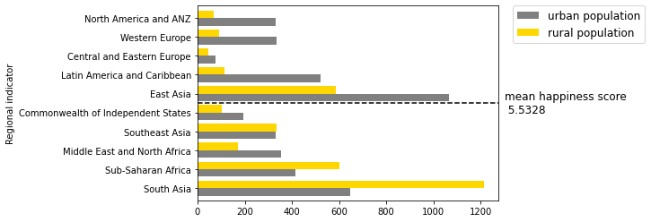

**Factors of life evaluation**

Plot shows that happiness level in Afganistan is 3 times lower than in Finland, social support and freedom of choice is twice lower

although the difference in grand domastic product and happy life expectancy is less than a 30%

It is also important to say that Finland political system is demorcatic, while Afghanistan is a dictatorship,

Correlation shows that nominal GDP which is useful in comparing national economies on the international market

Doesn’t measure the effect of the economy on human happiness.

**Usage of bar graph**: The bar graph is used to compare the happiness score of Afghanistan and Finland.

**Difference between Finland and Afghanistan: Top and Bottom of the World Happiness rank**

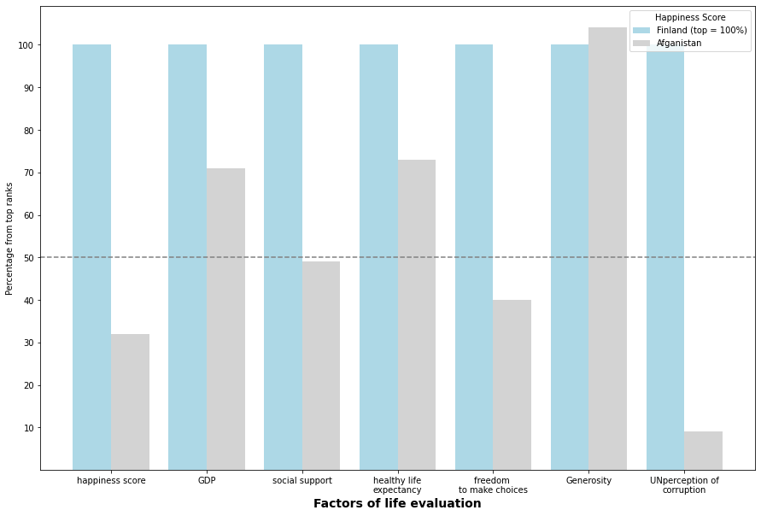

# Conclusion:

# We have boarded the 6 major factors of World happiness report by population and politics statistics. We uncover the scores of 149 countries, which ones emerged the happiest or unhappiest. We also look at the most and least happy countries in the world and summarize the features of happiness.

# Finally, we may conclude Such clear indicators as health and wealth, can help you live a relatively happy, comfortable life However, there’s much more to it than that. Happiness levels depend not just on financial security, but also broader perceptions of one’s social support, personal freedom and political regime of the country.